Spanish Cuisine.

Gazpacho. The reddest, ripest tomatoes, olive oil, garlic, bread, peppers and cucumber are blended until silky smooth, then chilled and poured into bowls or glasses. ...

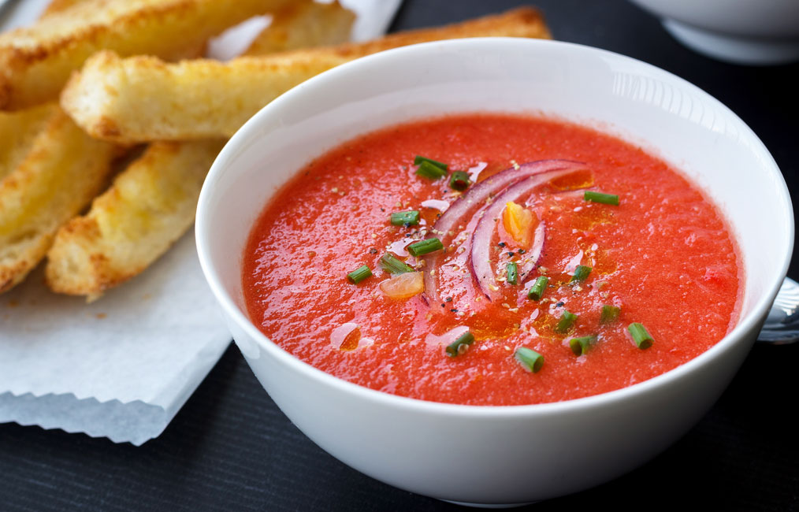

Paella.

...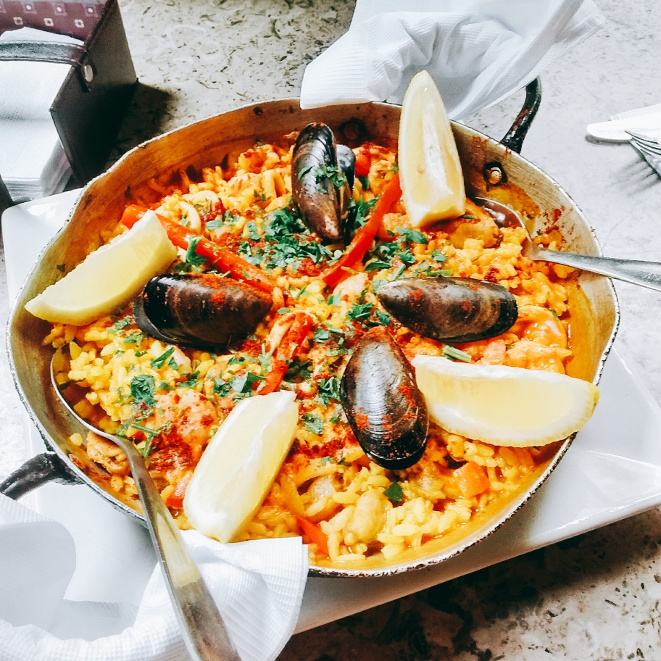

Tortilla Española. ...

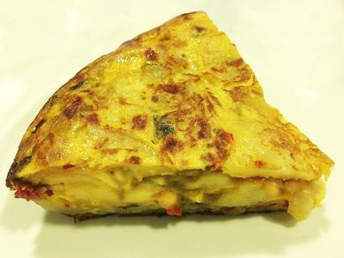

Gambas al ajillo. ...

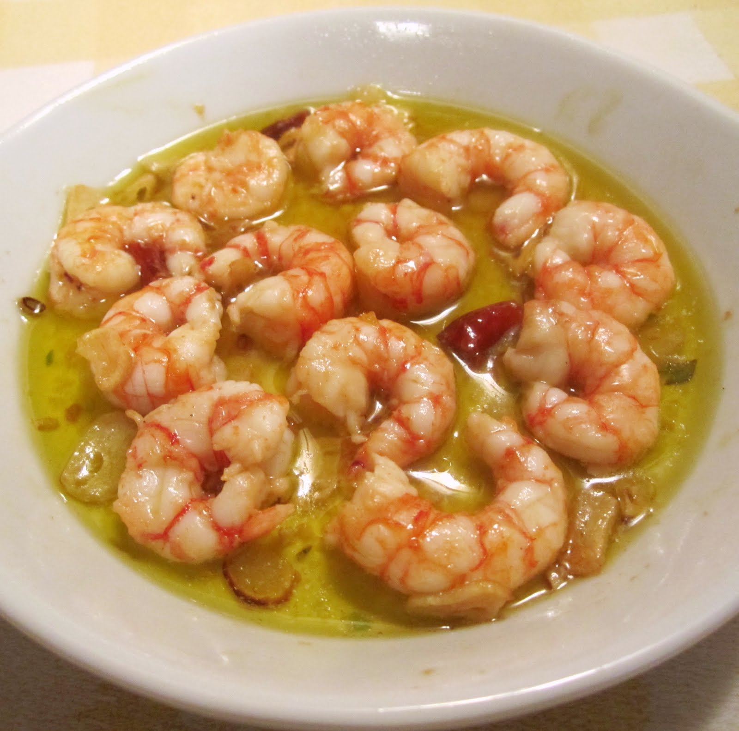

Tostas de tomate y jamón. ...

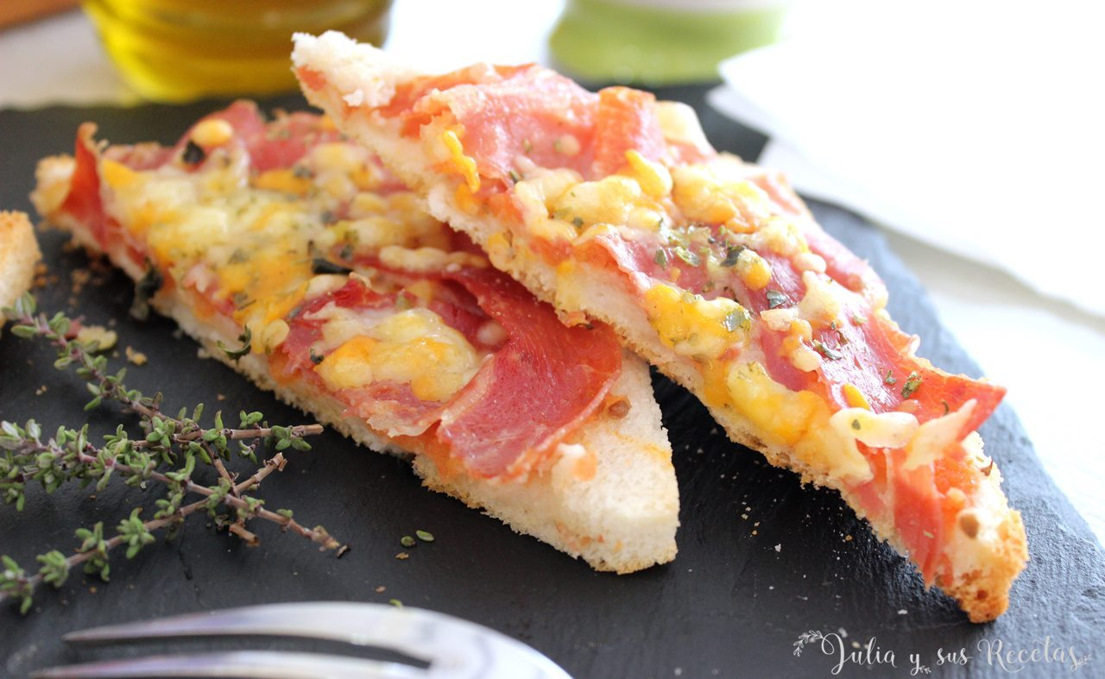

Patatas bravas. ...

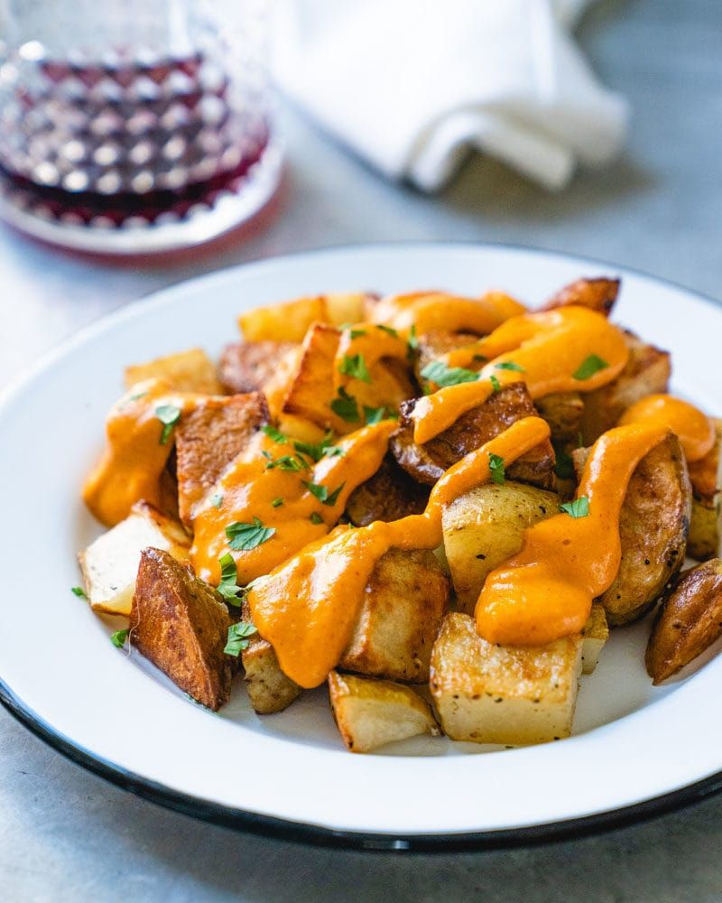

Pollo al ajillo. ...

Cochinillo asado

